**Incidents Management in ServiceNow**

**Document History**

|  |  |  |  |  |  |
| --- | --- | --- | --- | --- | --- |
| **Version** | **Release Date** | **Created By** | **Description of**  **Change** | **Genpact**  **Approval by** | **Customer**  **Approval by** |
| 1.0 |  |  |  |  |  |
|  |  |  |  |  |  |

**Terminology & Abbreviations used**

|  |  |
| --- | --- |
| Incidents | An occurrence of an action or situation that is a separate unit of experience |
| FTP/SFTP | Web server which is used to store the mapping and output files, it can be accessed to other if they have server credentials |
| Mapping file | Any type of file format, which is useful to store the config or input files |
| Web Table | The content of table which present in the web pages |
| Sorting | Arrange the required fields based on ascending/descending order |

**TABLE OF CONTENT**

1 Introduction 4

2 Overview 4

2.1 High Level Manual Process Description 4

2.2 Target Applications 5

2.3 Process Prerequisites 5

2.4 Definitions 5

3 Process Diagram - 6

4 Incident Management Process Description 7

5 Scheduling of Activities 7

6 User rights and access 7

# Introduction

This document provides a detailed and step by step understanding of “Incident creation in ServiceNow”. In this application, we can create/store list of service incidents in a web table format. First, we extract the top three incidents which exist in the web table incident list. Once we extract the incidents, that extracted information will be stored into a mapping excel sheet file. After that, will create some new incidents using those stored retrieved details from the mapping file. Then we extract the incident web table completely, and we segregate the incident based on status and will be stored in each excel sheet accordingly.

The purpose of the Incident Management process is to restore normal service operation as quickly as possible and minimize the adverse impact on business operations, ensuring that agreed levels of service quality are maintained.

The purposes of the Incident Management process are to:

• Ensure that standardized methods and procedures are used for efficient and prompt response, analysis, documentation, ongoing management and reporting of incidents

• Increase visibility and communication of incidents to business and IT support staff

• Enhance business perception of IT through use of a professional approach in quickly resolving and communicating incidents when they occur

• Align Incident Management activities and priorities with those of the business

• Maintain user satisfaction with the quality of IT services

# Overview

## High Level Manual Process Description

1. Open the “Services.com” site.
2. Login into the services application.
3. Find the Incidents, in the search tab
4. Retrieve the top three incidents information and store it into a excel sheet and upload the same excel file details to the server.
5. Get the incidents details mapping file from the server and create new incidents, using mapping file details.
6. New incidents will be included into Incidents web table.
7. Extract the Incidents web table and store the web table into excel sheet.
8. Sort the incidents based on Status.
9. Create different excel sheet and store all the incidents from the web table, based on each individual status and store it
10. Once we segregated the incidents, upload all the output files into server.

## Target Applications

The following applications / systems are necessary to have access to, in order to perform the Incident management

1. Microsoft Outlook
2. Microsoft Excel
3. Internet Explorer
4. Services Now application
5. FTP Server

## Process Prerequisites

1. Access to ServiceNow Application
2. Access to Microsoft applications – Excel and Outlook
3. Access to FTP Server

## Definitions

1. **Incidents**

Incident can refer to any event – big or small, good or bad, intentional or unintentional. An occurrence of an action or situation that is a separate unit of experience

1. **FTP/SFTP Server**

A secure FTP server helps users with transferring files over secure file transfer protocols such as SSH File Transfer Protocol or FTP with SSL/TLS. The transfers can be achieved through server-to-server or client-to-server configurations.

# Process Diagram -

Below is the high level process flow showing step by step movement of account creation request in the system

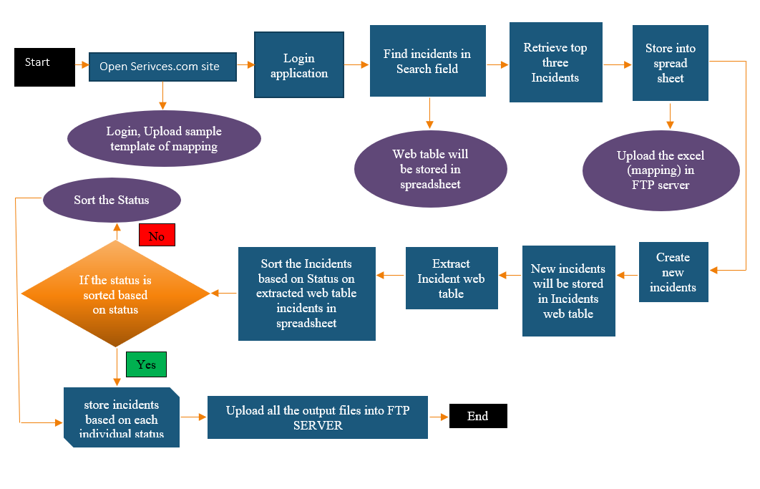

# Incident Management Process Description

Steps required to be followed for Incident Management:

1. Launch the Service.com web application through IE browser
2. Login into the Services application using the username and password
3. Once the application is launched, open the incidents.
4. To open incidents, in search field, find the incidents option, once the field are suggestion, click on incidents.
5. The Incidents web table will be shown, and it contains all the list of incidents will be present.
6. Retrieve top three incidents details and store it into the excel file (mapping file).
7. Login FTP/SFTP server with the admin credentials.
8. Then keep the mapping files and required templates into FTP server.
9. Create new incidents using the mapping files which contains all the incidents details (Download the mapping files from FTP server).
10. The newly created incidents will be included in the Incident web table.
11. Extract the Incident web table and store into the excel file.
12. Sort the incidents based on Status.
13. Create different excel sheet and store all the incidents from the web table, based on each individual status and store it
14. Once we segregated the incidents, upload all the output files into server.
15. Send the output files as attachment in the email to appropriate person.

# Scheduling of Activities

The frequency of “Incident Management” is based on requirement or any incidents occurred at that time we required to create an incident. Its frequencies are need basis in the services applications or user requirements.

# User rights and access

The FTP/SFTP server access is required to store the templates, mapping files and output files. Credentials required to login the services applications and additionally we need basic access for the Microsoft applications like excel and outlook to store incident details and send emails accordingly.